Harnessing data mining tools to evaluate the impact of the meat industry on climate.

Anmol Negi¹, Ishita Singh², Paridhi Gupta², Ashwina Prasad¹, Aayush Kukreja¹, Preeti Nandal², Vineeta Sharma², Jayant Maini²*
¹Department of Computer Sciences and Engineering, School of Engineering and Technology, Manav Rachna International Institute of Research and Studies, Faridabad, Haryana, India
²Department of Biotechnology, School of Engineering and Technology, Manav Rachna International Institute of Research and Studies, Faridabad, Haryana, India
*Corresponding Author
Correspondence at jayant.set@mriu.edu.in
Abstract

The meat and dairy industries have had a significant impact on climate change. Cattle alone contribute 13-17% of the greenhouse gas emissions annually along with the associated collateral damage of deforestation and antimicrobial resistance. To call attention to this issue, our team employed advanced data science techniques to extract insights from IPCC reports. Leveraging pyamihtml, pygetpapers and using docanalysis, we scrutinized specific sections related to food security in the IPCC reports followed by a supportive but independent literature survey, translating them into graphs, tables and CSV. files. We observed that a drastic increase in annual meat/milk production/consumption from the year 1990 to 2020, correlated with the increase in annual methane emissions for the same period, with cattle being a major contributor. With this correlation study, we are trying to bring a sharp focus on the problem of meat and dairy industries and its major contribution to the threat we face in the form of climate change. The initial project with preliminary analysis was showcased at the Semantic Climate Hackathon, 2024 held at Manav Rachna International Institute of Research and Studies, Faridabad, with the aim of highlighting the adverse impacts of the meat and dairy industry on climate change. This study seeks to instill informed decision making and collaborative action towards a sustainable future, tackling a small portion of the massive issue of climate change.

KeyWords: meat industry, data mining, IPCC, pyamihtml, pygetpapers, docanalysis

Key Points
- The IPCC report- and literature-based survey & analysis adds to the growing amount of evidence regarding the significant role of the meat and dairy industry in exacerbating the negative effects of climate change.
- Using data from various studies, we correlate livestock number, meat slaughter/production, milk production and methane emission in India.
- We further observe the negative correlation between state-wise total livestock, meat/milk production and methane emissions with that of state-wise forest cover.

Introduction

India shows a great diversity in dietary habits which are influenced by cultural, religious and economic factors. Although a vast majority of people in India are vegetarians, population explosion, urbanization, changing lifestyle and rising income has directly or indirectly led to an increase in meat and milk consumption. This in turn has led to a boom in meat and dairy industry in India, that generally encompasses a variety of livestock which includes cattle, poultry, sheep and goats. Although the meat and dairy industry in India, have contributed significantly to nation’s development providing employment opportunities, molding agricultural landscape and economy, its environmental impact cannot be denied or ignored. With respect to meat and dairy farming, each livestock contributes differently to the greenhouse gas emission and environmental degradation. The meat and dairy industries, other than impacting the environment (Godde et al., 2021¹; Cassandra Brooks, 2011²) effect land use and deforestation (Jesse Peterson, 2024)³, water usage and pollution as well as resource depletion [4] (Humane Foundation, 2023)⁴. As mentioned earlier, livestock production is responsible for a sizeable portion of methane emissions, a byproduct of digestive processes in ruminating animals (Nejad et al. 2023)⁵. Large-scale deforestation is allowed to make way for creating pastureland and growing feed crops, which as an additional burden releases carbon dioxide stored in trees thereby impacting planet's capacity to absorb atmospheric CO₂ (Kateryna Sergieieva, 2023)⁶. In addition, the relentlessly extensive use of antibiotics in animal farming contributes to the growing compliation of antimicrobial resistance (Manyi-Loh et al. 2018)⁷. These factors cumulatively make the meat and dairy industry a major driver of environmental degradation, highlighting the urgent need for sustainable practices such as dietary shifts to mitigate its impact. The impact of climate change such as increasing temperatures and changing precipitation patterns are already affecting the security of food systems and negative impacts are expected to increase based on future projected climate change, resulting in further declines of crop yields and increasingly food prices (IPCC Report - SRCCL)⁸. Hence, awareness about climate change is crucial for developing a global commitment to environmental sustainability.
The goal of this study is to first and foremost “free” the knowledge from “locked literature”, like the IPCC and annual Indian reports, to correlate multiple datasets and present a comprehensive cause and effect relationship, if possible and if not to provide research gaps, to provide a knowledge base which will act as “launch pad” for policy makers and last but not the least foster collaborative action towards a climate friendly future. Taking the above mentioned into consideration, we started by focusing on SRCCL [Special Report on Climate Change and Land, Chapter 5 - Food Security from the AR6 (Assessment Report 6) of the IPCC]⁸ report which highlights how climate change impacts food security, encompassing food stability, availability and affordability. Additionally, it proposes strategies for adapting to these changes by reducing greenhouse gas emissions from food production and work on sustainable land management to enhance food security. Through case studies and examples, it provides valuable insights into these interconnected issues. The information required to undertake current study was filtered out and modified using various tools and libraries like pyami, docanalysis, and pygetpapers. Through this modification, data embedded in the report was extracted in the form of .csv files which was then used to generate useful visual representations. Apart from this, useful information from a range of sources, including academic papers (NIH, PubMed) and datasets (kaggle) on topics like livestock farming, consumption trends, and environmental consequences, were collated. Quality check of the gathered data was done to validate its reliability and appropriateness.

Methodology
The data was extracted from the Intergovernmental Panel on Climate Change (IPCC)⁸ report and analyzed to identify the role of the meat industry in environmental degradation. We focused on the fifth chapter of the report on Food Security of the SRCCL (Special Report on Climate Change and Land)⁸ and various other data sources, including scholarly articles, Indian government reports, and datasets related to livestock production, consumption, and environmental impacts. Furthermore, the team verified the collected data to ensure its quality and suitability for analysis.
We then worked on establishing a methodological framework for the analysis, considering the objectives of the research and the nature of the data. This step involved the selection of appropriate data science techniques and text mining tools such as pyamihtml, pygetpapers and docanalysis. The pipeline involved converting the report into HTML format, parsing the text, and identifying key passages related to food security and the meat industry. Statistical analysis was conducted through matplotlib.pyplot to examine trends and patterns in livestock production and consumption over time.
We then analyzed the extracted data to assess the impact of the meat industry on climate change and food security. This involved exploring correlations, trends, and associations between variables such as livestock production and greenhouse gas emissions. Visualizations, such as graphs, charts, and maps, were created to illustrate the findings of the analysis. This facilitated the communication of complex relationships and trends in a clear and accessible manner. After required survey and analysis, the visual representation of relevant information was carried out.
The Spatial maps of India depicting state-wise total livestock (in numbers), state-wise methane emission from livestock (gigagram per year), state-wise production of milk (‘000 Tonnes) and state-wise percentage of forest (area under forest/total area of each state) were created using excel from the data for the year 2019 from literature (India State of Forest Report, Forest Survey of India, Ministry of Environment, Forest & Climate Change, Government of India, 2019⁹; National Dairy Development Board (2019)¹⁰; Animal Husbandry and Dairying, Ministry of Fisheries, Government of India Report, 2021¹¹; Samal et al., 2024¹²).

Result and discussions
According to the IPCC report (section 1.4.3), India along with China and Indonesia contribute to 50% global greenhouse gas emissions but the role of the meat and dairy industry in methane emissions in India have not been explored. Hence, this prompted us to focus on the Indian scientific literature and various other websites. Following this survey, we were able to collate and then correlate the data on livestock number, meat consumption, meat production, meat export, milk production, methane emissions and deforestation. In the subsequent paragraphs, we discuss the results obtained from the literature-based survey and meta-analysis.
The period between 1990-2024 (Figure 1A), shows a marked increase in meat consumption (Kg per capita). Predictions beyond 2024, point toward the continuation of the same trend. Although, Beef shows a marked decline after 2013-14, the poultry consumption shows a steady increase. On the contrary milk production has been on a steady rise (Figure 1B). Hence, meat consumption to some extent and dairy farming puts a heavy burden on the environment.

Figure-1 A. The above graph highlights meat consumption (Kg per capita) from the year 1990 to 2028 [Source]¹⁸. B. The figure depicts milk production in Million Tonnes) from 1991 to 2023 [National Dairy Development Board (2019) {Source}¹⁰].

This trend indicates a growing demand for meat and milk (which is itself correlated to population explosion and its dependence on meat for nutrition), which could have implications for agricultural practices, food supply chains, and environmental impacts. This data is supported by a study (Devi et al.,2014)¹³, where the per capita meat consumption for goat, beef, pork and chicken is 0.053 Kg, 0.037 Kg, 0.006Kg and 0.059Kg, respectively (Devi et al.,2014)¹³. According to this study, herd expansion (Bovine herd) showed a correlated increase with meat production (Beef production) between 2003 to 2013). According to an article in The Guardian (Milman, 2021)¹⁴, beef-based food contributes to 4 billion metric tonnes of greenhouse gas emission globally.

Figure 2 A. Figure compares chicken, goat, pig, lamb and duck with respect to number of animals slaughtered from the year 1990 to 2024 [Source]¹⁹. B. The data for goat, pig, lamb and duck has been shown in high resolution. C The figure exclusively focuses on cattle slaughtered in numbers (1000 head) [Source]²⁰.

The consumption of poultry meat in India (Figure 1A) shows a correlation to Chicken slaughter as shown in Figure 2A. In comparison, even though beef consumption is on the decline in India, it is one of the largest beef exporters second only to Brazil (Fleck, 2024)¹⁵, the beef consumption (Figure 1A) doesn’t correlate with cattle slaughter and meat production (Figure 2C).

Following this, we studied methane emissions in India from 1990 to 2024 and found that the methane emissions show a steady increase (ourworldindata.org), very similar to meat consumption, milk production and cattle slaughter. This increase in emissions may be attributed to changes in increased livestock populations, agricultural practices, and possibly changes in livestock management over the years.

Figure 3 The figure is a line plot depicting methane emissions from 1990 to 2024 [Source]²¹.

We understand the apart from meat and dairy industries, methane emission may be contributed by other factors such as fossil fuels and landfill waste (Pearce, 2016)¹⁶, but we do see a correlation in the trend over the years. These trends have important implications for environmental policies and efforts to mitigate greenhouse gas emissions.

For the ease of understanding, we created spatial maps for India depicting state wise total livestock (in number) and milk production (‘000 tonnes) and compared it to that of methane emission from livestock (Gigagram per year) and percentage geographical region under forest for the year 2019. The data for 2019 was chosen because of the availability of complete datasets for ease of comparison (India State of Forest Report, Forest Survey of India, Ministry of Environment, Forest & Climate Change, Government of India, 2019⁹; National Dairy Development Board (2019)¹⁰; Animal Husbandry and Dairying, Ministry of Fisheries, Government of India Report, 2021¹¹; Samal et al., 2024¹²). The spatial maps clearly show that states that have a) high total livestock (in numbers) such as Uttar Pradesh, Rajasthan, Madhya Pradesh, Maharashtra, Andhra Pradesh, Karnataka, Bihar, West Bengal and b) high milk production in states such Uttar Pradesh, Rajasthan, Madhya Pradesh, Gujarat, Maharashtra and Andhra Pradesh correlated significantly with methane emissions (in states such as Uttar Pradesh, Rajasthan, Madhya Pradesh, Gujarat, Maharashtra and Karnataka. The data on total livestock and methane production inversely correlated with state-wise forest cover with states such as Uttar Pradesh, Rajasthan, Maharashtra, Madhya Pradesh showing reduced forest area while states such as Uttarakhand, Himachal, Arunachal Pradesh, Manipur, Tripura, Chhattisgarh and Odisha show high forest cover.

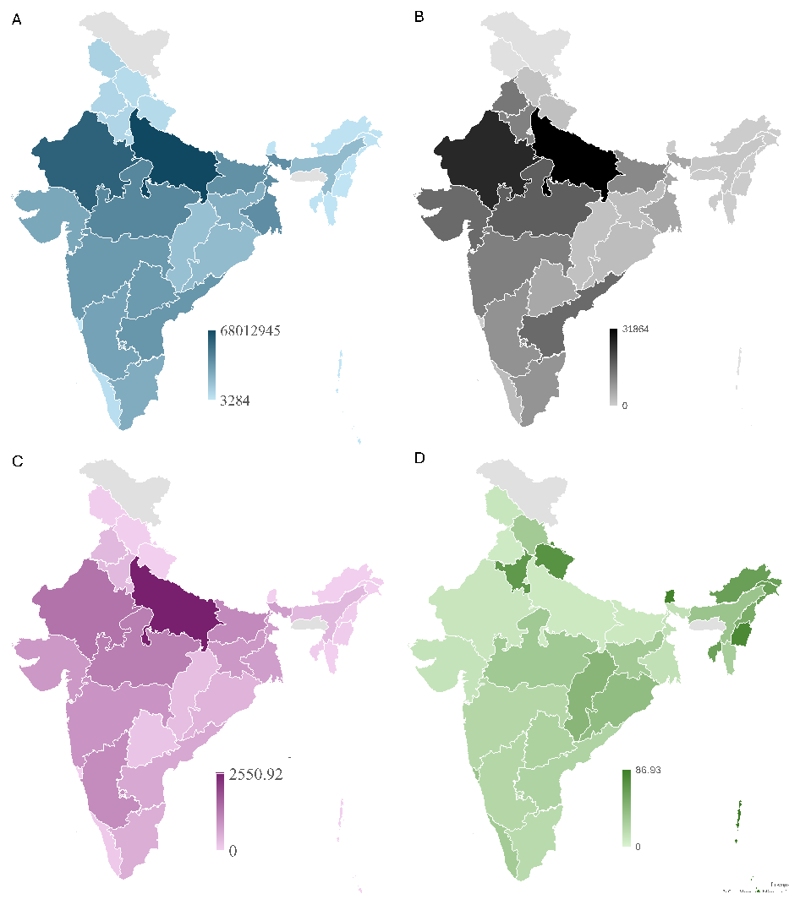
Figure 4: The figure shows spatial maps for India depicting state-wise total livestock (in number in shades of blue) and milk production (‘000 tonnes in shades of gray) and compared it to that of methane emission from livestock (Gigagram per year, in shades of pink) and percentage geographical region under forest for the year 2019 (% in shades of green). The data for 2019 was chosen because of the availability of complete datasets for ease of comparison (India State of Forest Report, Forest Survey of India, Ministry of Environment, Forest & Climate Change, Government of India, 2019⁹; National Dairy Development Board (2019)¹⁰; Animal Husbandry and Dairying, Ministry of Fisheries, Government of India Report, 2021¹¹; Samal et al., 2024¹²)

Indians in the 21st century are experiencing changes in lifestyle and food habits coupled with a population surge. The per capita annual consumption of meat has increased to 4.4 kg per person and is placing pressure on production lines. This, in turn, has resulted in greater demands for water and land resources for rearing livestock affecting forest cover (Kapoor, 2019)¹⁷. If this trend continues, it will lead to irreversible damage caused by greenhouse gas emission and pushing climate change to the point of no return.

Conclusion
Climate change is one of the most pressing global issues that we face today. Through this study we wish to highlight the significant role of the meat and dairy industry in contributing to climate change (greenhouse gas emission especially methane emissions) while stating the utmost urgency of addressing this issue. By employing advanced data science techniques to extract insights from IPCC reports as well as independent literature survey, the team was able to analyze specific sections related to food security and meat consumption, revealing alarming and correlated trends in annual meat consumption, meat production, milk production and methane emissions from cattle. This technical contribution not only sheds light on the environmental impacts of the meat and dairy industry but also seeks to inform decision-making and initiate collaborative action towards a sustainable future. By leveraging text mining and data visualization tools, this program enables stakeholders to extract valuable information from research sources embedded in IPCC chapters, facilitating evidence-based policy development and mitigation strategies. Although, there are many challenges, there is hope since a number of initiatives are being taken and sustainability efforts being put to action, these include a) shifting to organic farming which helps in reduction of chemical input, b) bringing about technological innovation in improving feed efficiency, waste management and integration with renewable energy and c) last but not the least by introducing policies promoting sustainability and environmental conservation in meat industries. This study emphasizes the importance of addressing the meat and dairy industry's contribution to climate change and environmental degradation through informed decision-making and collective efforts towards sustainability.

References
- Impacts of climate change on the livestock food supply chain; a review of the evidence C.M. Godde, D. Mason-D’Croz, D.E. Mayberry, P.K. Thornton, and M. Herrero Glob Food Sec. 2021 Mar; 28: 100488. Published online 2021 Mar. doi: 10.1016/j.gfs.2020.100488
- Cassandra Brooks, Stanford's Woods Institute, 2011 URL-https://woods.stanford.edu/news/meats-environmental-impact#:~:text=Livestock%20production%20accounts%20for%2018,private%20agencies%20based%20at%20FAO
- Jesse Peterson, earth.org, 2024 URL- https://earth.org/how-animal-agriculture-is-accelerating-global-deforestation/#:~:text=The%20primary%20catalyst%20behind%20global,the%20size%20of%20the%20Netherlands.
- Confronting the Truth: The Catastrophic Effects of the Meat Industry on Our World , Humane Foundation, December 20, 2023 URL-https://www.linkedin.com/pulse/confronting-truth-catastrophic-effects-meat-industry-qaure/
- Advances in Methane Emission Estimation in Livestock: A Review of Data Collection Methods, Model Development and the Role of AI Technologies Jalil Ghassemi Nejad, Mun-Su Ju, Jang-Hoon Jo, Kyung-Hwan Oh, Yoon-Seok Lee, Sung-Dae Lee, Eun-Joong Kim, Sanggun Roh, and Hong-Gu Lee ). doi: 10.3390/ani14030435
- Kateryna Sergieieva, 2023, Deforestation & Greenhouse Gases: Why Do Forests Matter. URL- https://eos.com/blog/deforestation-and-greenhouse-gases/
- Antibiotic Use in Agriculture and Its Consequential Resistance in Environmental Sources: Potential Public Health Implications Christy Manyi-Loh, Sampson Mamphweli, Edson Meyer, and Anthony Okoh doi: 10.3390/molecules23040795
- IPCC Special Report on Climate Change, Desertification, Land Degradation, Sustainable Land Management, Food Security, and Greenhouse Gas Fluxes in Terrestrial Ecosystems. pp. 437 – 550, Cambridge Unversity Press, 2022 https://doi.org/10.1017/9781009157988.007
- India State of Forest Report, Forest Survey of India, Ministry of Environment, Forest & Climate Change, Government of India, 2019
- National Dairy Development Board Report (2019) (https://www.nddb.coop/information/stats)
- Animal Husbandry and Dairying, Ministry of Fisheries, Government of India Report, 2021
- Samal, A., Sahu, S.K., Mishra, A., Mangaraj, P., Pani, S.K., Beig, G. (2024). Assessment and Quantification of Methane Emission from Indian Livestock and Manure Management. Aerosol Air Qual. Res. 24, 230204. https://doi.org/10.4209/aaqr.230204
- Devi SM, Balachandar V, Lee SI, Kim IH. An Outline of Meat Consumption in the Indian Population - A Pilot Review. Korean J Food Sci Anim Resour. 2014;34(4):507-15. doi: 10.5851/kosfa.2014.34.4.507. Epub 2014 Aug 31. PMID: 26761289; PMCID: PMC4662155.
- Milman O. Mear accounts for nearly 60% of all greenhouse gases from food production, study finds. The Gaurdian. Sep 2021
- Anna Fleck, Indian Emerges as Second Largest Beef Exporter in the World, The Wire, March 05, 2024
- Fred Pearce, What is Causing the Recent Rise in methane Emissions?, Yale Environment 360, October, 25, 2016
- Kapoor Y. How is India’s meat industry impacting the environment? IndiaBioscience Oct 12, 2019 (https://indiabioscience.org/columns/indian-scenario/meating-the-needs-of-the-future)
- https://github.com/yutan16/meatconsumption/blob/main/meat_consumption.csv
- Yearly number of animals slaughtered for meat, World (ourworldindata.org) Yearly number of animals slaughtered for meat, World, 1961 to 2022 (ourworldindata.org)
- Cattle Total Slaughter by Year https://www.indexmundi.com/agriculture/?country=in&commodity=cattle&graph=total-slaughter#google_vignette
- Annual Methane Emissions (1850 to 2022) (Methane emissions, 2022 (ourworldindata.org)

